# Department of Software Engineering

**CS 432: Distributed Computing**

**Lab 01: Multi Threading**

**Date: January 30 and January 31, 2025**

**Instructors: Dr. Shah Khalid, Dr. Khurram Shahzad**

**Submitted by: Haseeb Muhammad**

**Qalam ID: 413927**

**Class: BSCS 12 A**

**Experiments Table:**

Number of steps: 100000

|  |  |  |
| --- | --- | --- |
| **Experiment No** | **Single Thread (microsecond)** | **Multithread (microsecond)** |
| 1 | 15749 | 15831 |
| 2 | 15082 | 17421 |
| 3 | 19410 | 16440 |
| **Average** | **16747** | **16564** |

Number of steps: 10000000

|  |  |  |
| --- | --- | --- |
| **Experiment No** | **Single Thread (microsecond)** | **Multithread (microsecond)** |
| 1 | 29000 | 27896 |
| 2 | 30997 | 27021 |
| 3 | 30151 | 27449 |
| **Average** | **30049** | **27455** |

**Results explanation:**

The multi-threaded approach consistently performs faster than the single-threaded one, as evidenced by the lower average execution time. This improvement is due to the effective distribution of the computational workload across multiple threads, which reduces the overall processing time.

**Code without Threads**

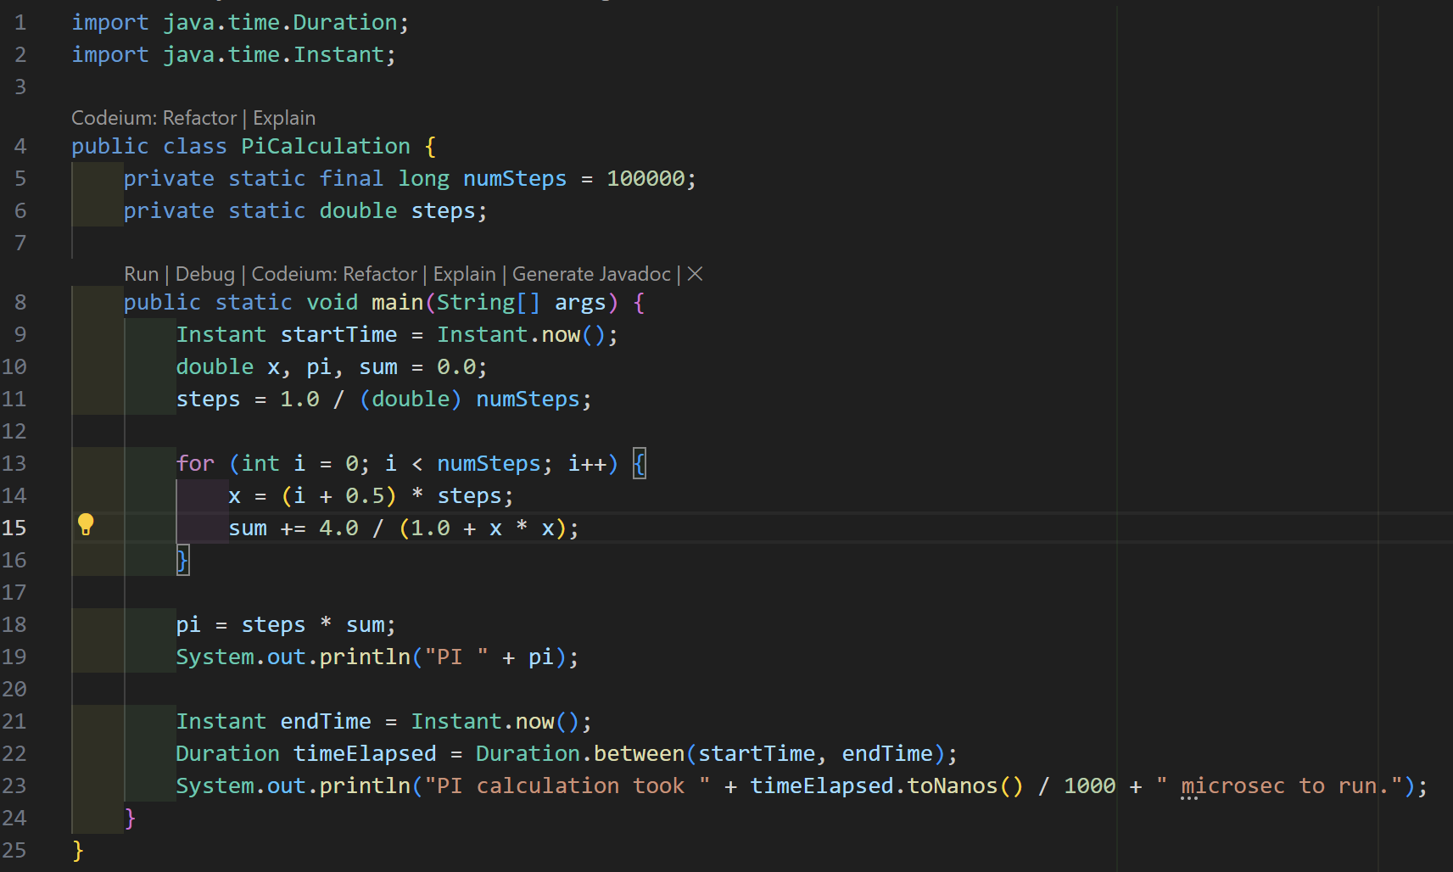

**Code with Threads**

